SQL Query Outputs for Adidas Sales Database
Query 1:
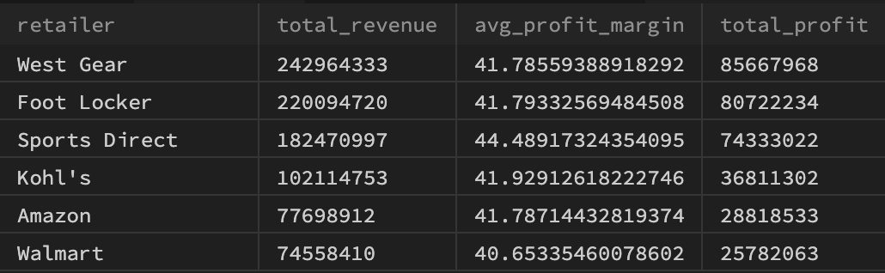
Query 2:
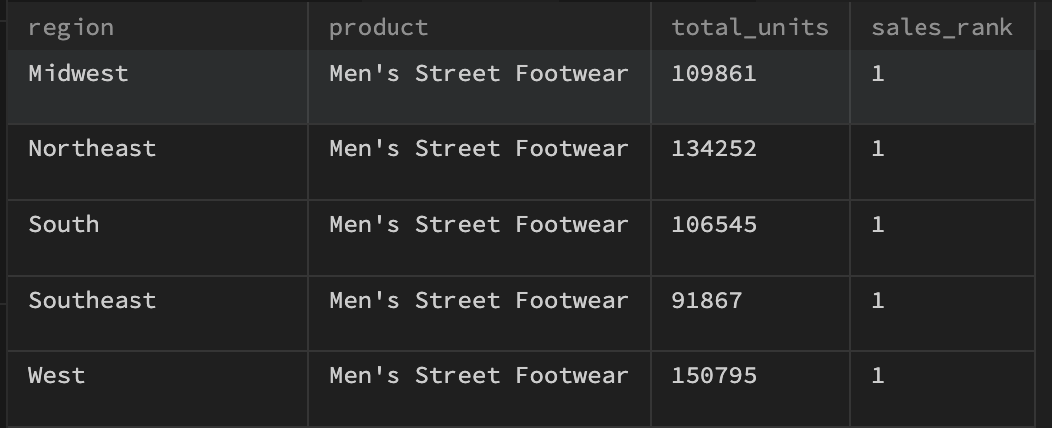
Query 3:
